Báo cáo OOP lab04: Inheritance and Polymorphism

Họ và tên: Nguyễn Văn Thái MSSV: 20215135

Contents

0. Assignment Submission 2

1. Import the existing project into the workspace of Eclipse 2

2. Additional requirements of AIMS 2

3. Creating the Book class 2

4. Creating the abstract Media class 2

5. Creating the CompactDisc class 2

5.1. Create the Disc class extending the Media class 2

5.2. Create the Track class which models a track on a compact disc and will store information incuding the title and length of the track 2

5.3. Open the CompactDisc class 2

6. Create the Playable interface 2

7. Update the Cart class to work with Media 2

8. Update the Store class to work with Media 2

9. Constructors of whole classes and parent classes 2

10. Unique item in a list 2

11. Polymorphism with toString() method 2

12. Sort media in the cart 2

13. Create a complete console application in the Aims class 2

1. Assignment Submission
2. Import the existing project into the workspace of Eclipse
3. Additional requirements of AIMS
4. Creating the Book class

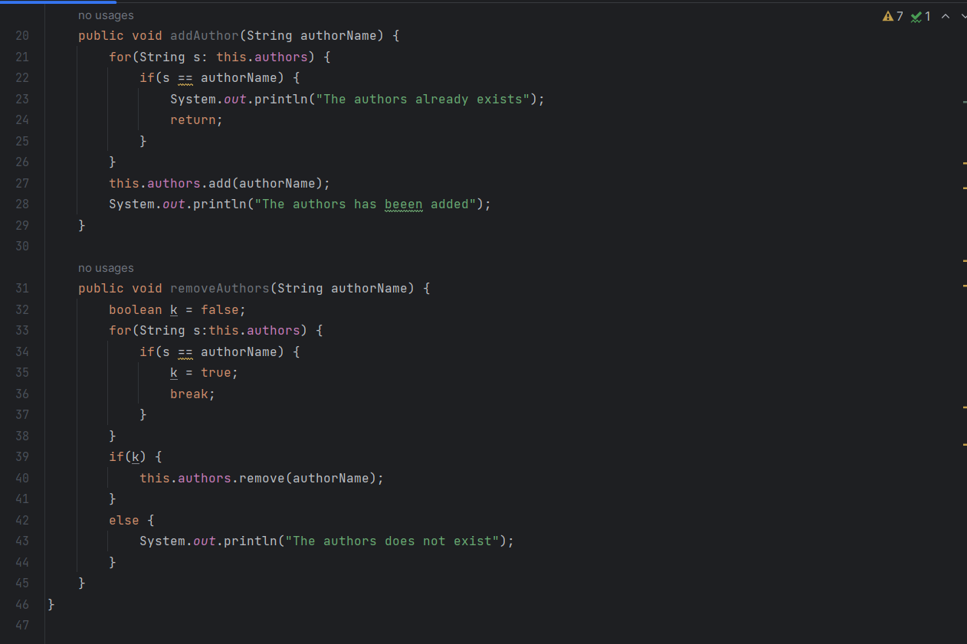

1. Creating the abstract Media class

1. Creating the CompactDisc class
   1. Create the Disc class extending the Media class

* 1. Create the Track class which models a track on a compact disc and will store information incuding the title and length of the track

* 1. Open the CompactDisc class

1. Create the Playable interface

1. Update the Cart class to work with Media

1. Update the Store class to work with Media

1. Constructors of whole classes and parent classes

1. Unique item in a list

1. Polymorphism with toString() method

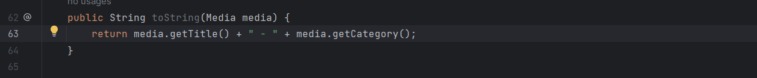

1. Sort media in the cart

Trả lời câu hỏi có thể thực hiện như sau để kiểm tra đồng thời title và cost

1. Create a complete console application in the Aims class

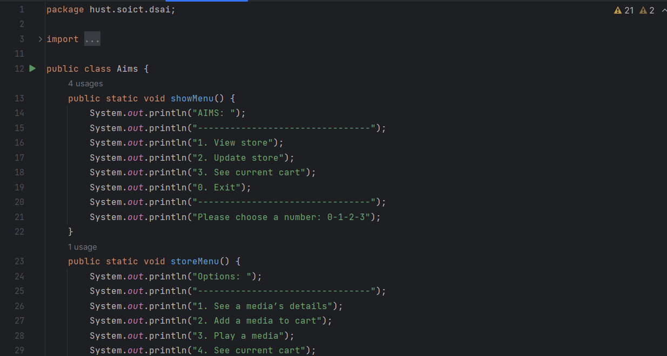

Có thể xem thêm ở trong code